World’s Oldest Businesses Analysis
- Project Overview
The purpose of this project was to analyze the world’s oldest businesses, the industries they belong to and their locations in the world. The goal was to gain insights about the oldest businesses, the reason behind their longevity, popular industries, and in which countries / continents those businesses and industries take precedence.
- Dataset Summary
- Tables: 3
- Total Columns: 9
- Total Rows: 377
- Business Table include columns such as year founded, country code, etc.
- Categories Table include columns such as category code and the corresponding category (industry)
- Countries Table include columns such as country code and the corresponding country
- Missing Data: None

- Exploratory Data Analysis using Postgres
Goal: Clean data and check for null values
Process: - Each table was reviewed manually for spelling error, extra white spacing, data type match and inconsistencies in the data
- Each table was reviewed manually for any null values. No null values were found in the data.
- Next, the SQL querying of the data begin.

- Data Analysis with PostgreSQL
- The range of the founding years of the oldest companies in the world
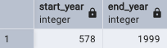
The range of founding years are from 578 AD to 1999.
- The oldest company in the world and the industry it belongs to

Kongo Gumi, a Japanese construction company is considered the oldest company in the world. The longevity of the company can be attributed to choosing a stable product (Buddhist temples) for its’ region and the ability to pivot during unstable times, such as when sales declined after WW2 and the company switched to building coffins until sales improved.
- How many companies — and which ones — were founded before 1000 AD
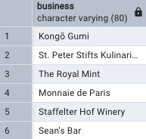
The above companies are all location in the Eastern part of the world.
- The most common industries to which the oldest companies belong to
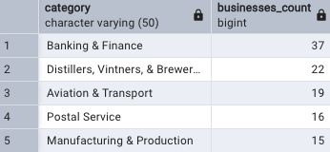
Banking & Finance is self explanatory as to its longevity and popularity. Wineries and breweries were second due to a history involving safety, necessity, monasteries, and just the overall history of the industry in different cultures.
- The oldest companies by continent
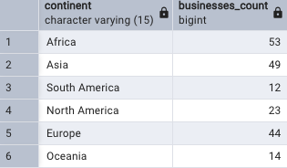
Africa has the largest number of oldest companies due to the continents’ natural resources and the colonial era.

- The most common industries for the oldest companies on each continent
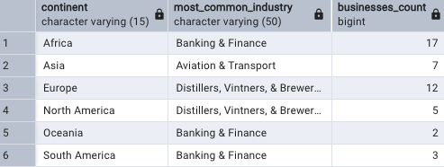

- Data Visualization using Tableau and a Map
